**Movie Recommendation System**

Author: Ramesh Talapaneni

Bellevue University – DSC 650-T302: Big Data

Instructor: Nasheb Ismaily

Date: February 17, 2025

# Environment Setup

## Start VM

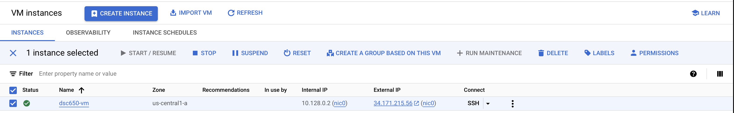

## SSH into VM

|  |
| --- |
| ssh **ramesh.tallapaneni@**34.171.215.56 |

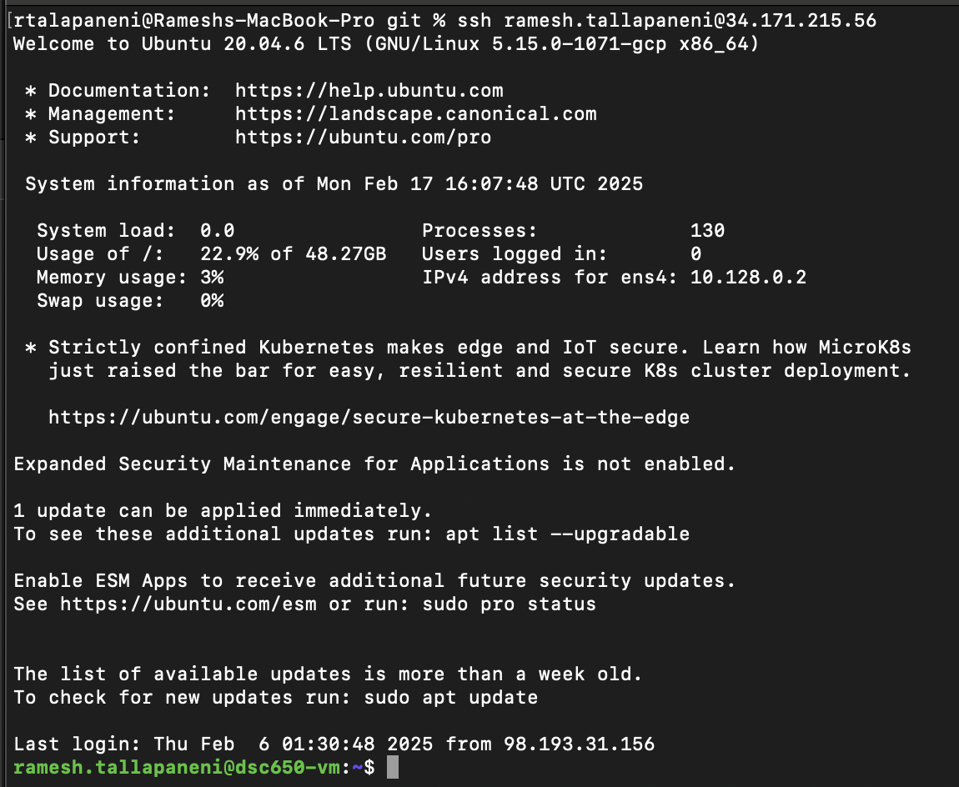

## Configure for local terminal access

|  |
| --- |
| ssh -L 9870:localhost:9870 -L 8088:localhost:8088 -L 8080:localhost:8080 -L 18080:localhost:18080 -L 16010:localhost:16010 -L 8983:localhost:8983 -L 8443:localhost:8443 **ramesh.tallapaneni@**34.171.215.56 |

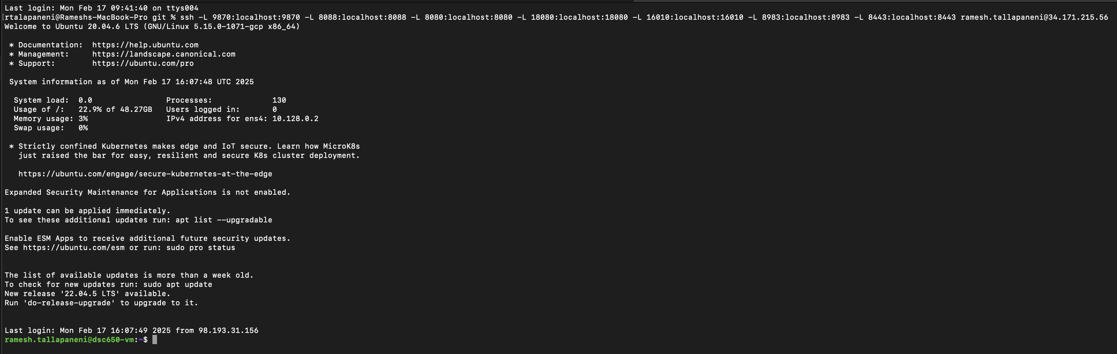

## Start Hadoop

|  |
| --- |
| cd dsc650-infra/bellevue-bigdata/hadoop-hive-spark-hbase |
| docker-compose up -d |

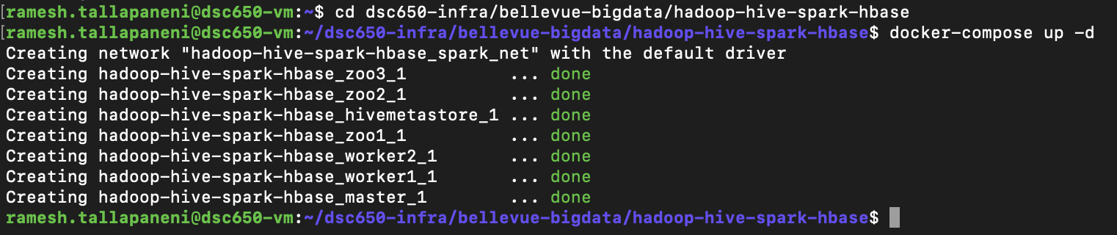

## Start NiFi

|  |
| --- |
| cd dsc650-infra/bellevue-bigdata/nifi |
| /bin/bash nifi-*/bin/nifi.sh start |

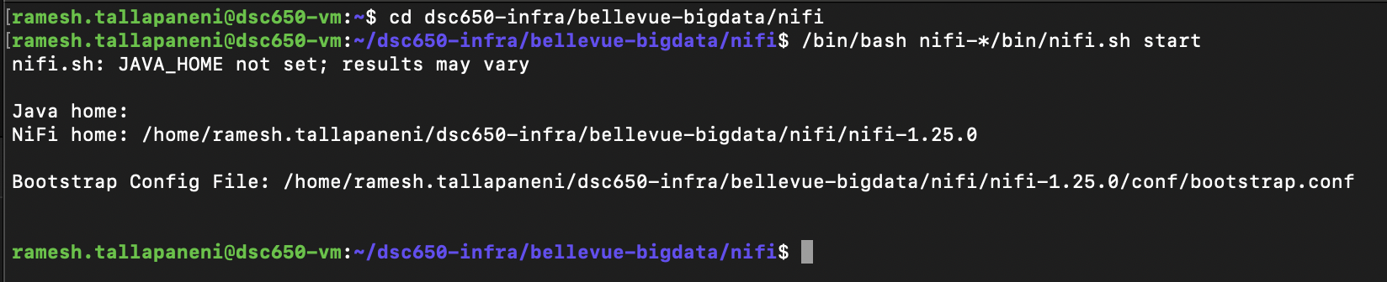

## Start Hive

|  |
| --- |
| docker-compose exec master bash |
| hive |

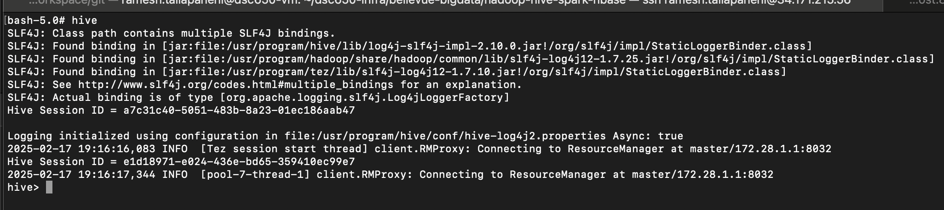

## Start PySpark

|  |
| --- |
| spark-submit --class org.apache.spark.examples.SparkPi \  --master yarn \  --deploy-mode client \  --driver-memory 2g \  --executor-memory 1g \  --executor-cores 1 \  $SPARK_HOME/examples/jars/spark-examples*.jar \  10 |
| $SPARK_HOME/bin/spark-shell --master yarn --driver-memory 2g --executor-memory 1g --executor-cores 1 |

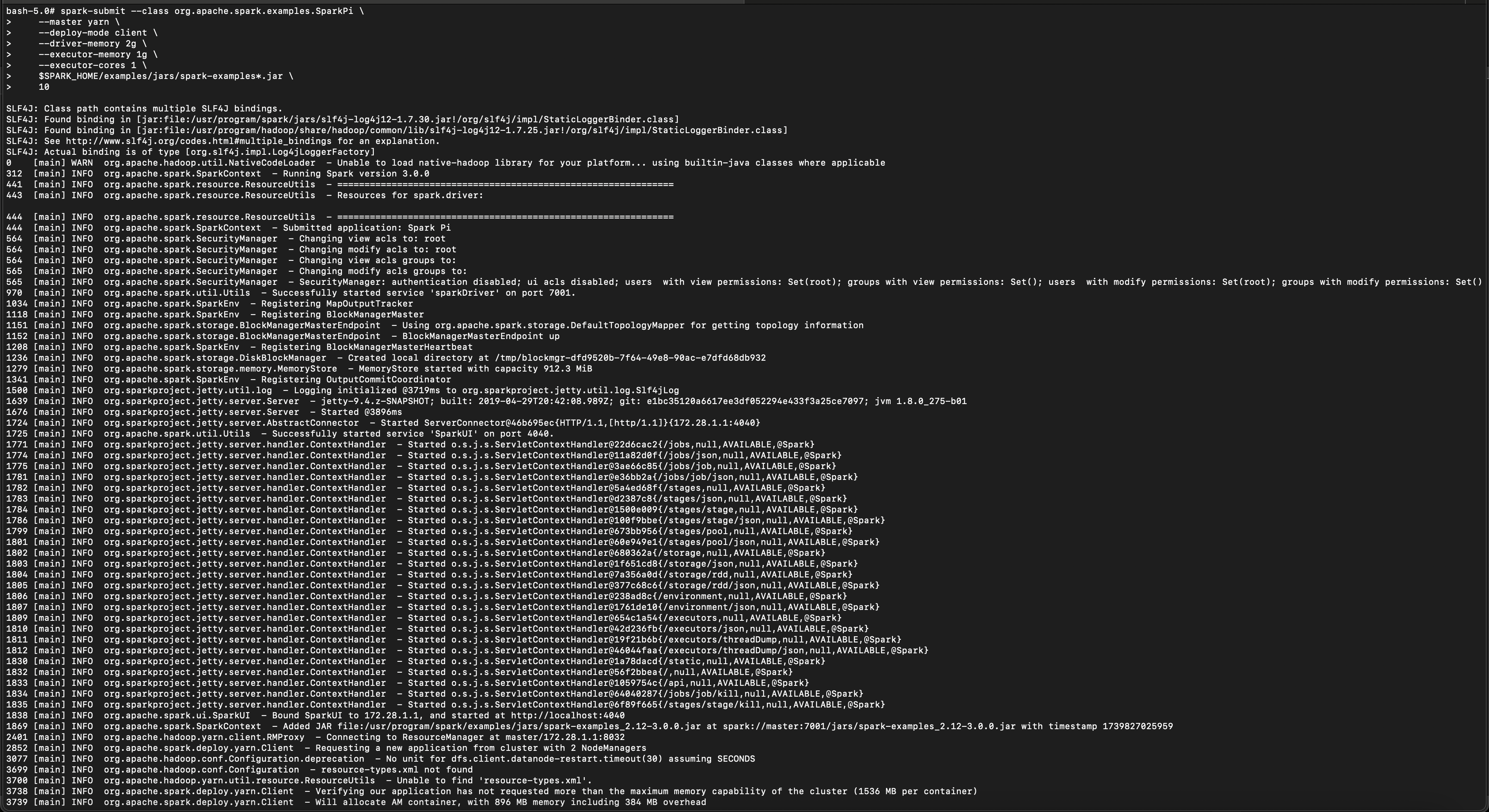

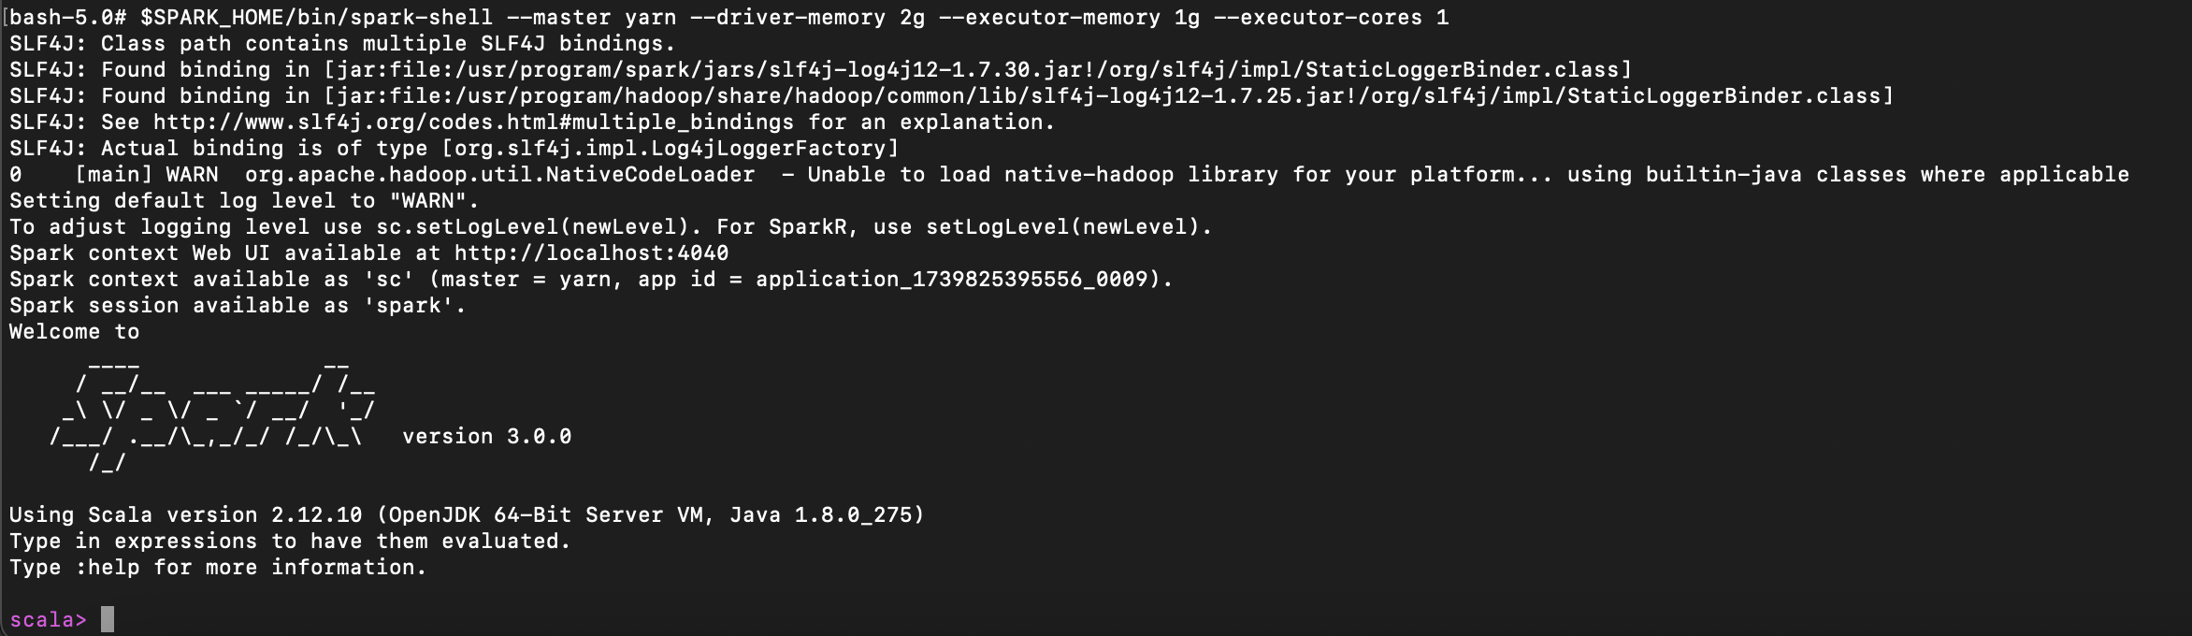

# Project Execution

## Create movie data storage directory in hdfs

|  |
| --- |
| docker-compose exec master bash |
| hdfs dfs -ls / |
| hdfs dfs -mkdir /movie-data |
| hdfs dfs -ls /movie-data |

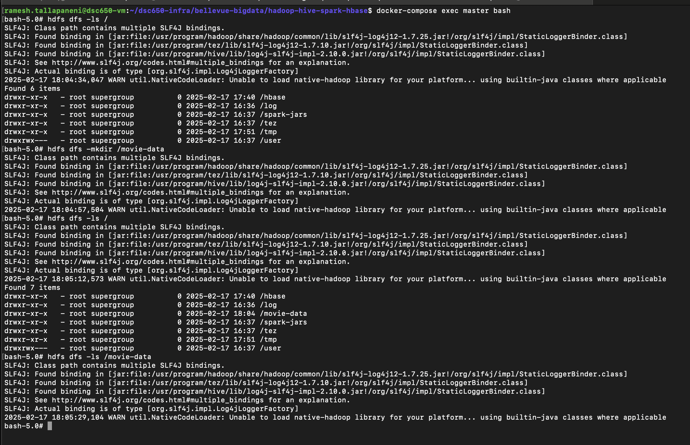

## Access NiFi web interface

|  |
| --- |
| https://localhost:8443/nifi/ |

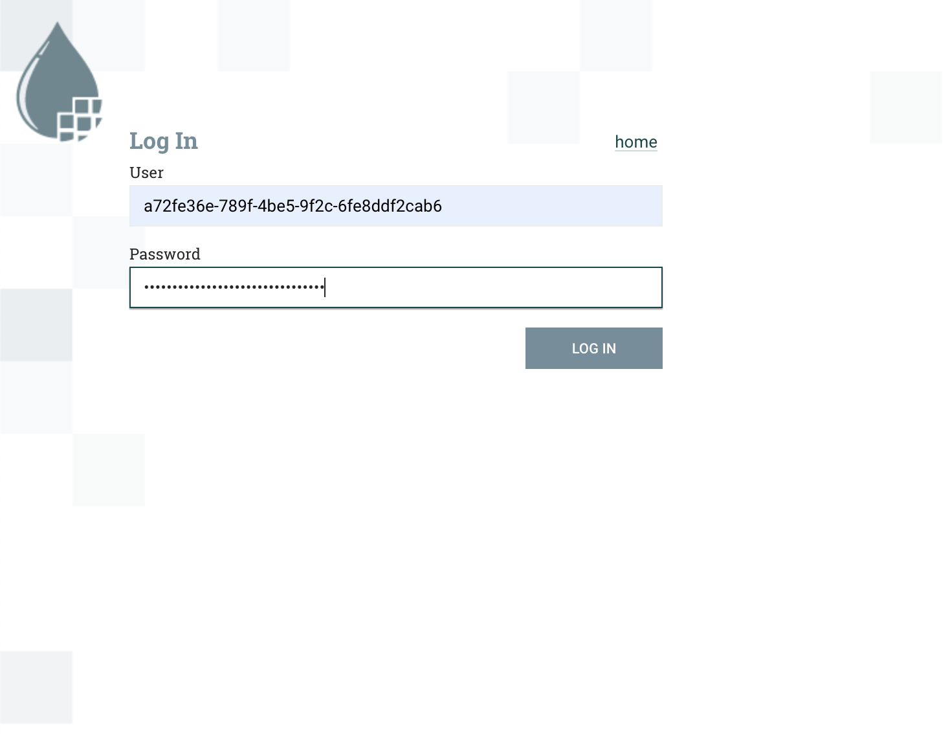

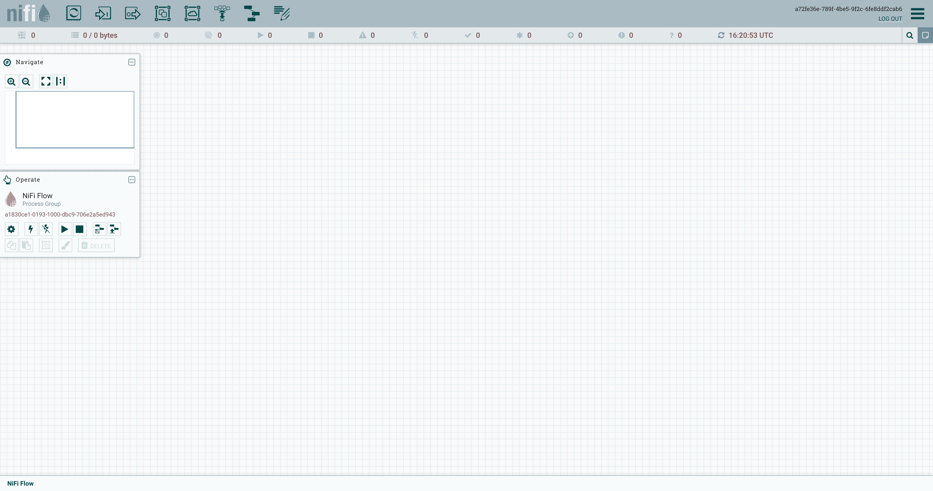

## Create Pipeline

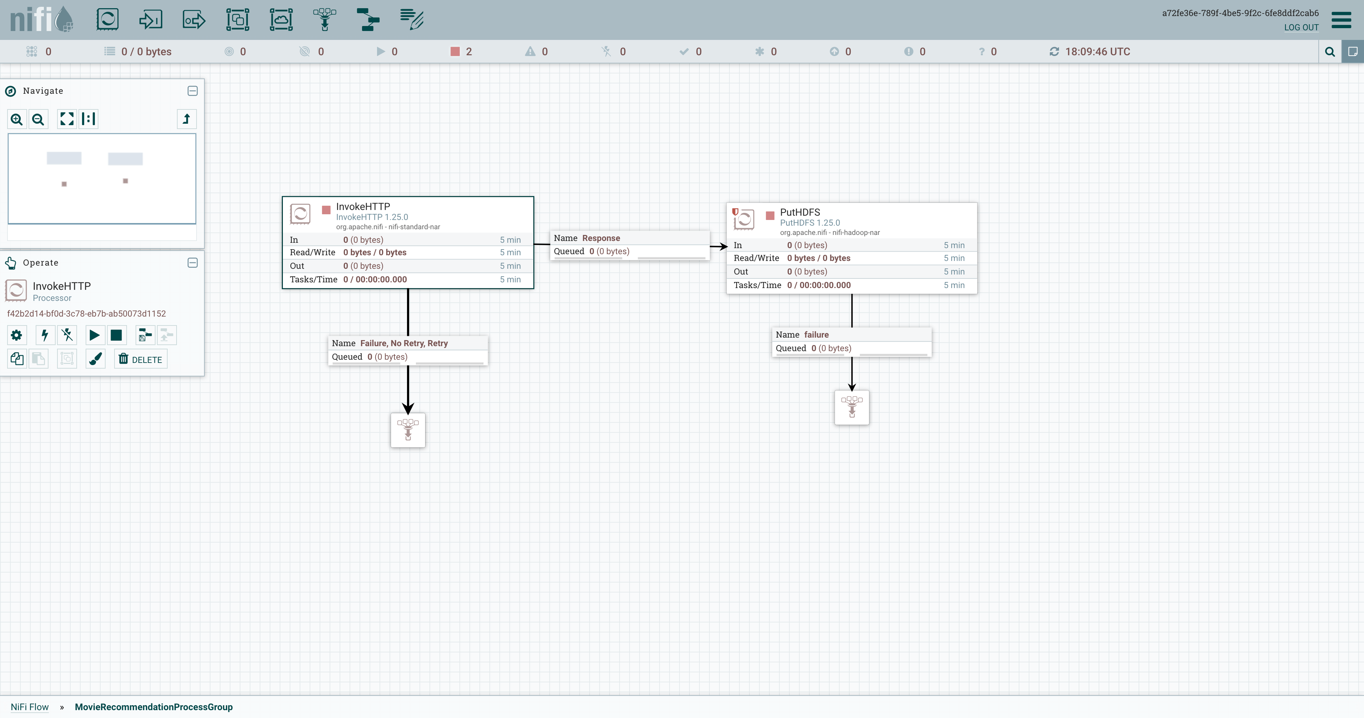

### Configure to download movie data from git-hub

|  |
| --- |
| Use raw data as https://raw.githubusercontent.com/rtalapaneni/tgc-movie-recommendation-system/refs/heads/main/tgc-movie-recommendation-system-data/tmdb_5000_movies.csv |

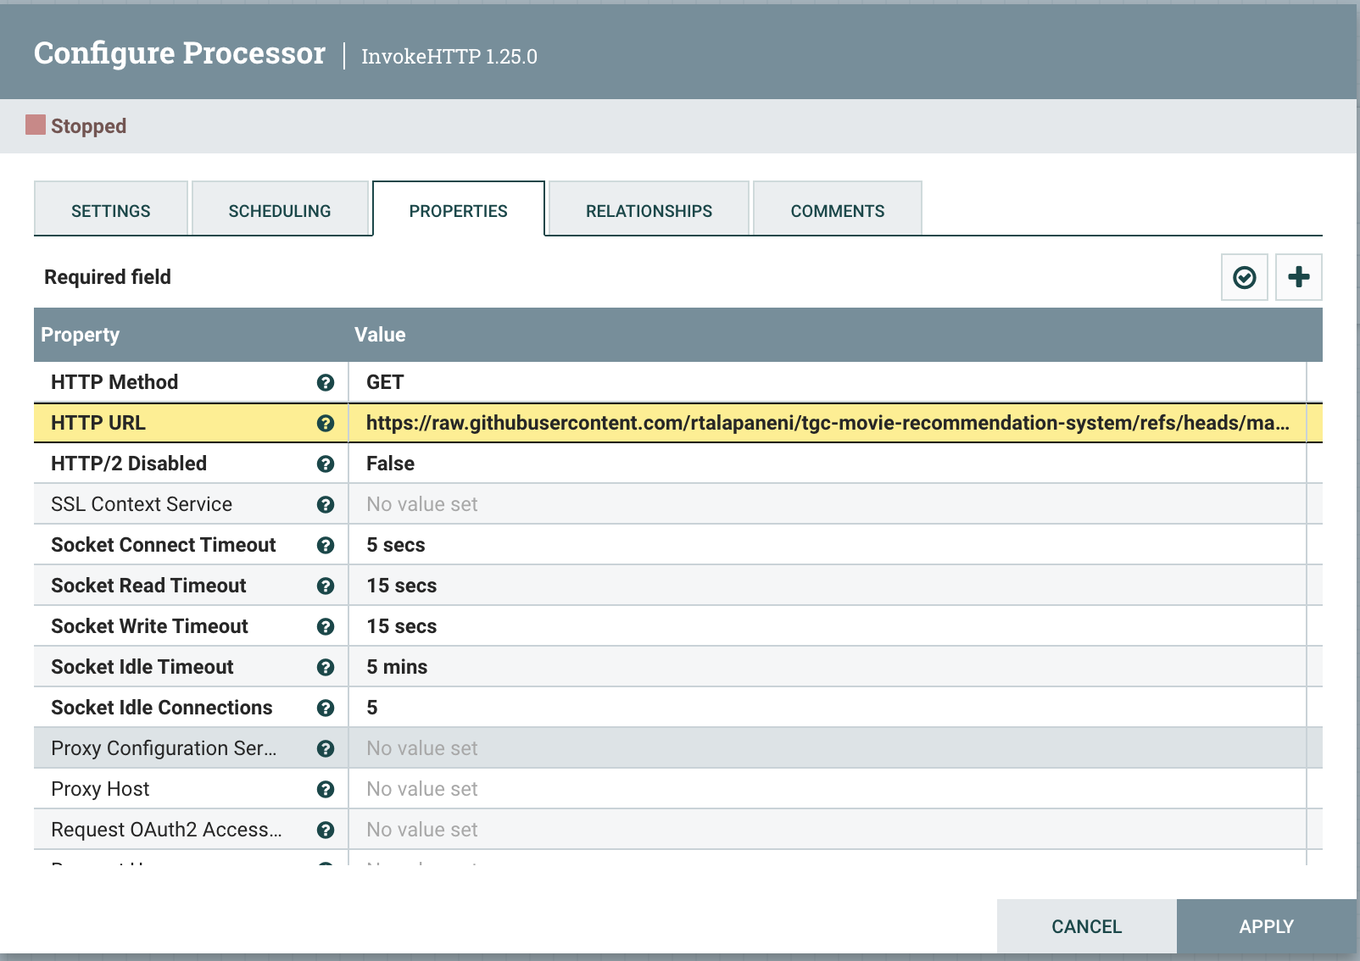

### Configure to upload the data to hdfs folder

|  |
| --- |
| Use the path - /movie-data |

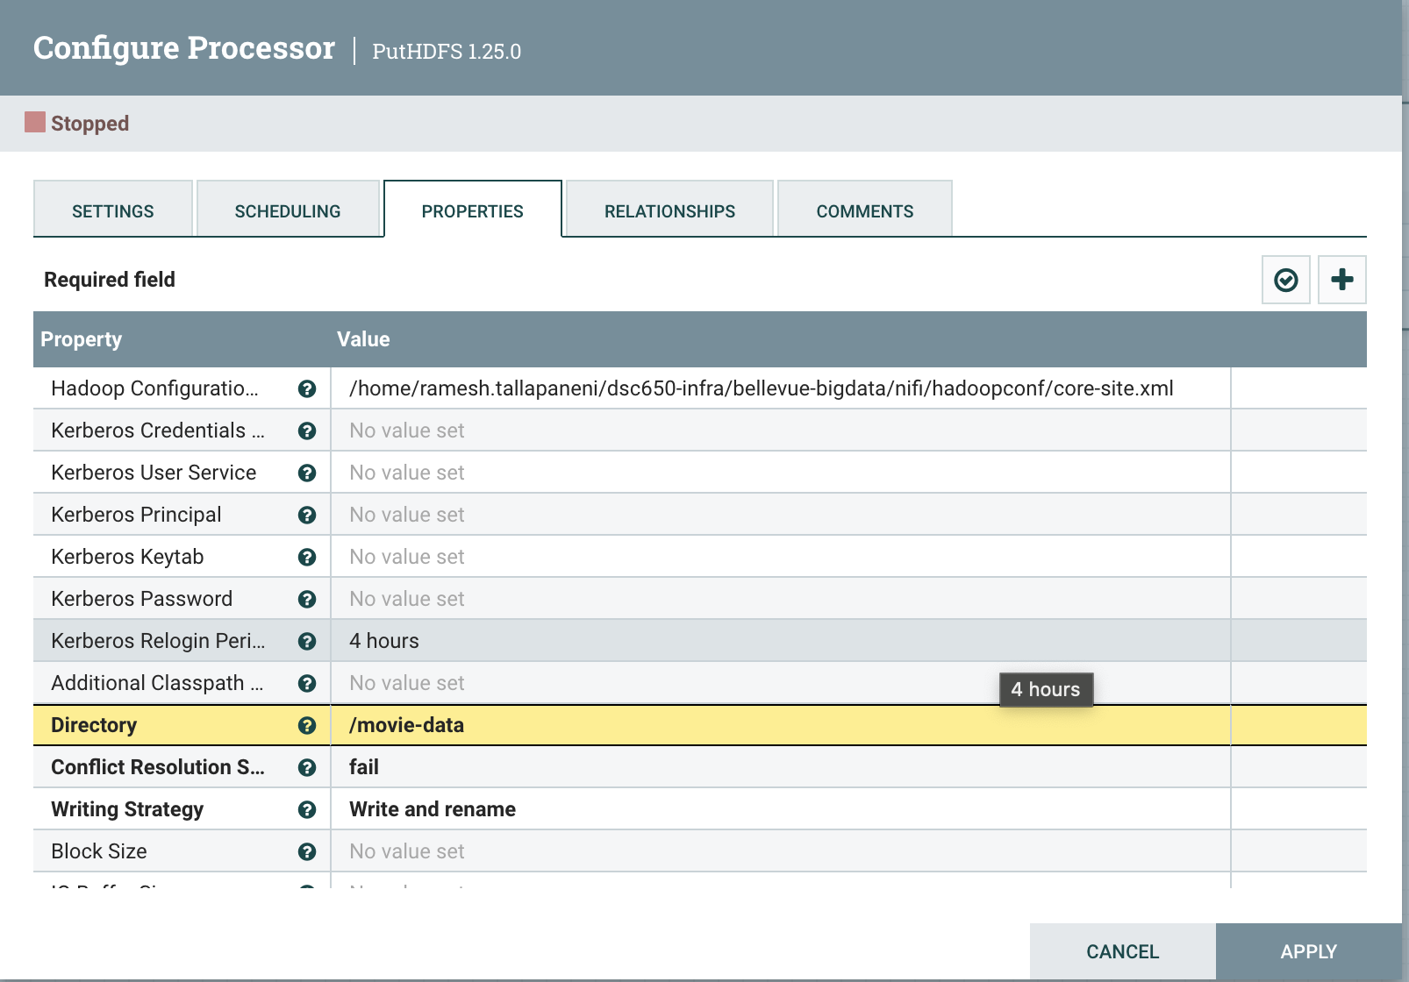

### Run the pipeline

#### Run the InovkeHTTP Processor Once

##### Before Running

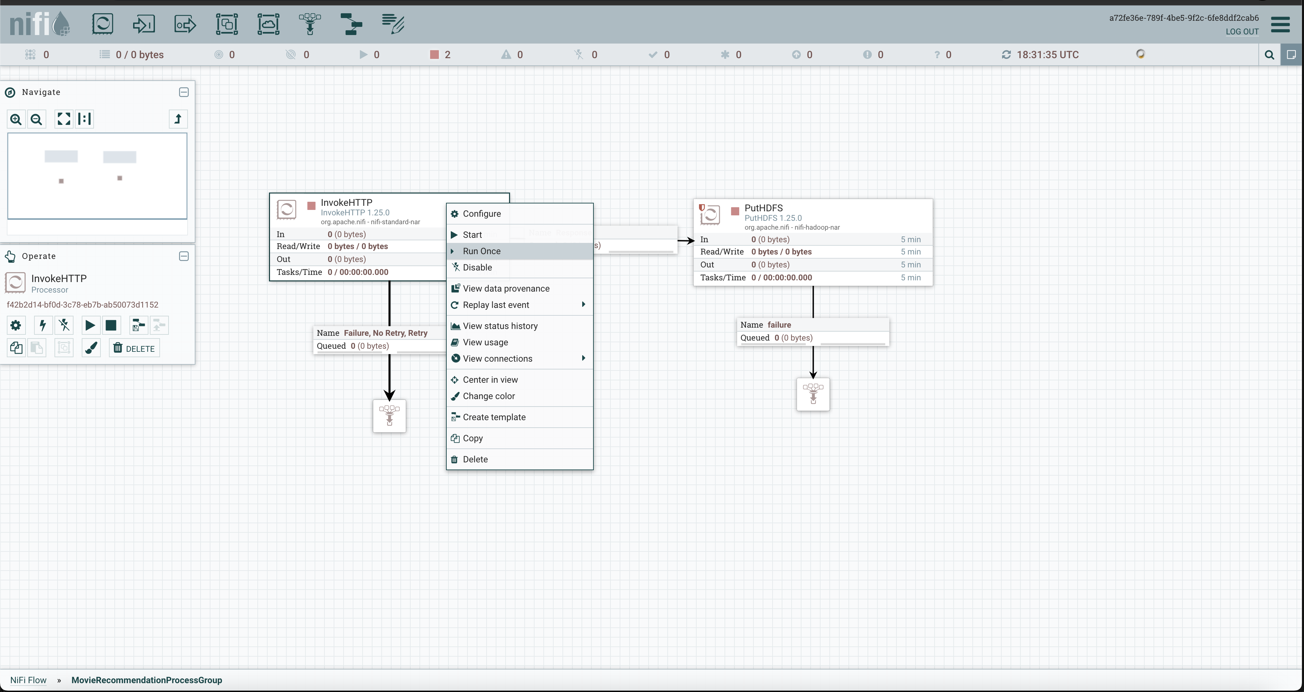

##### After Running

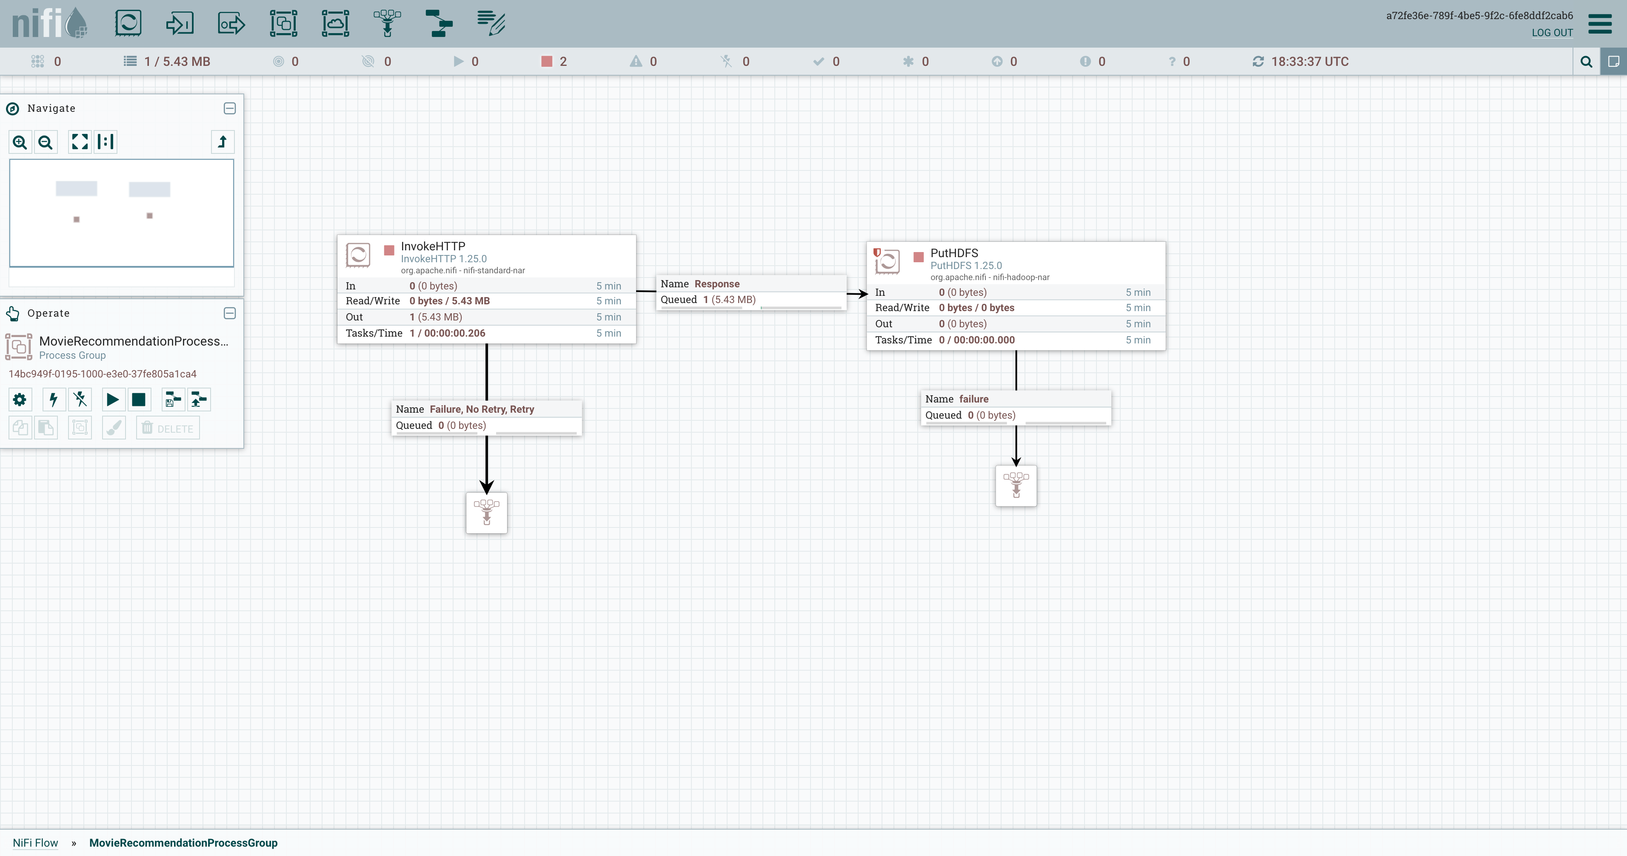

#### Run the PutHDDFS Processor Once

##### Before Running

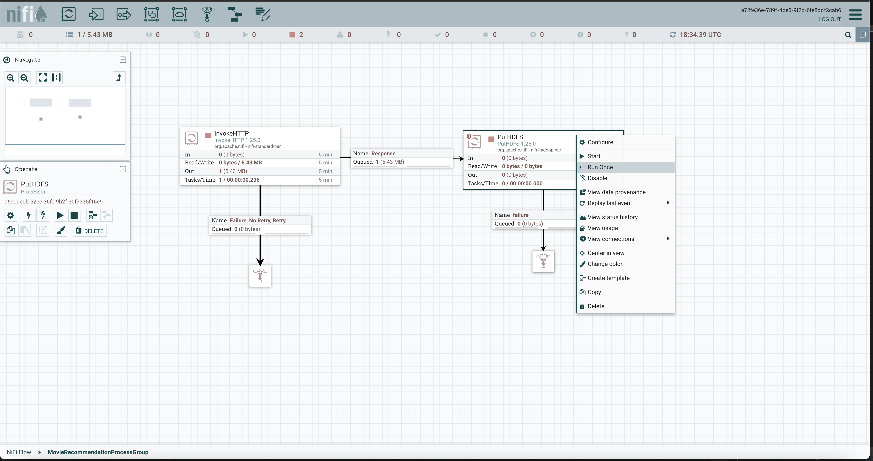

##### After Running

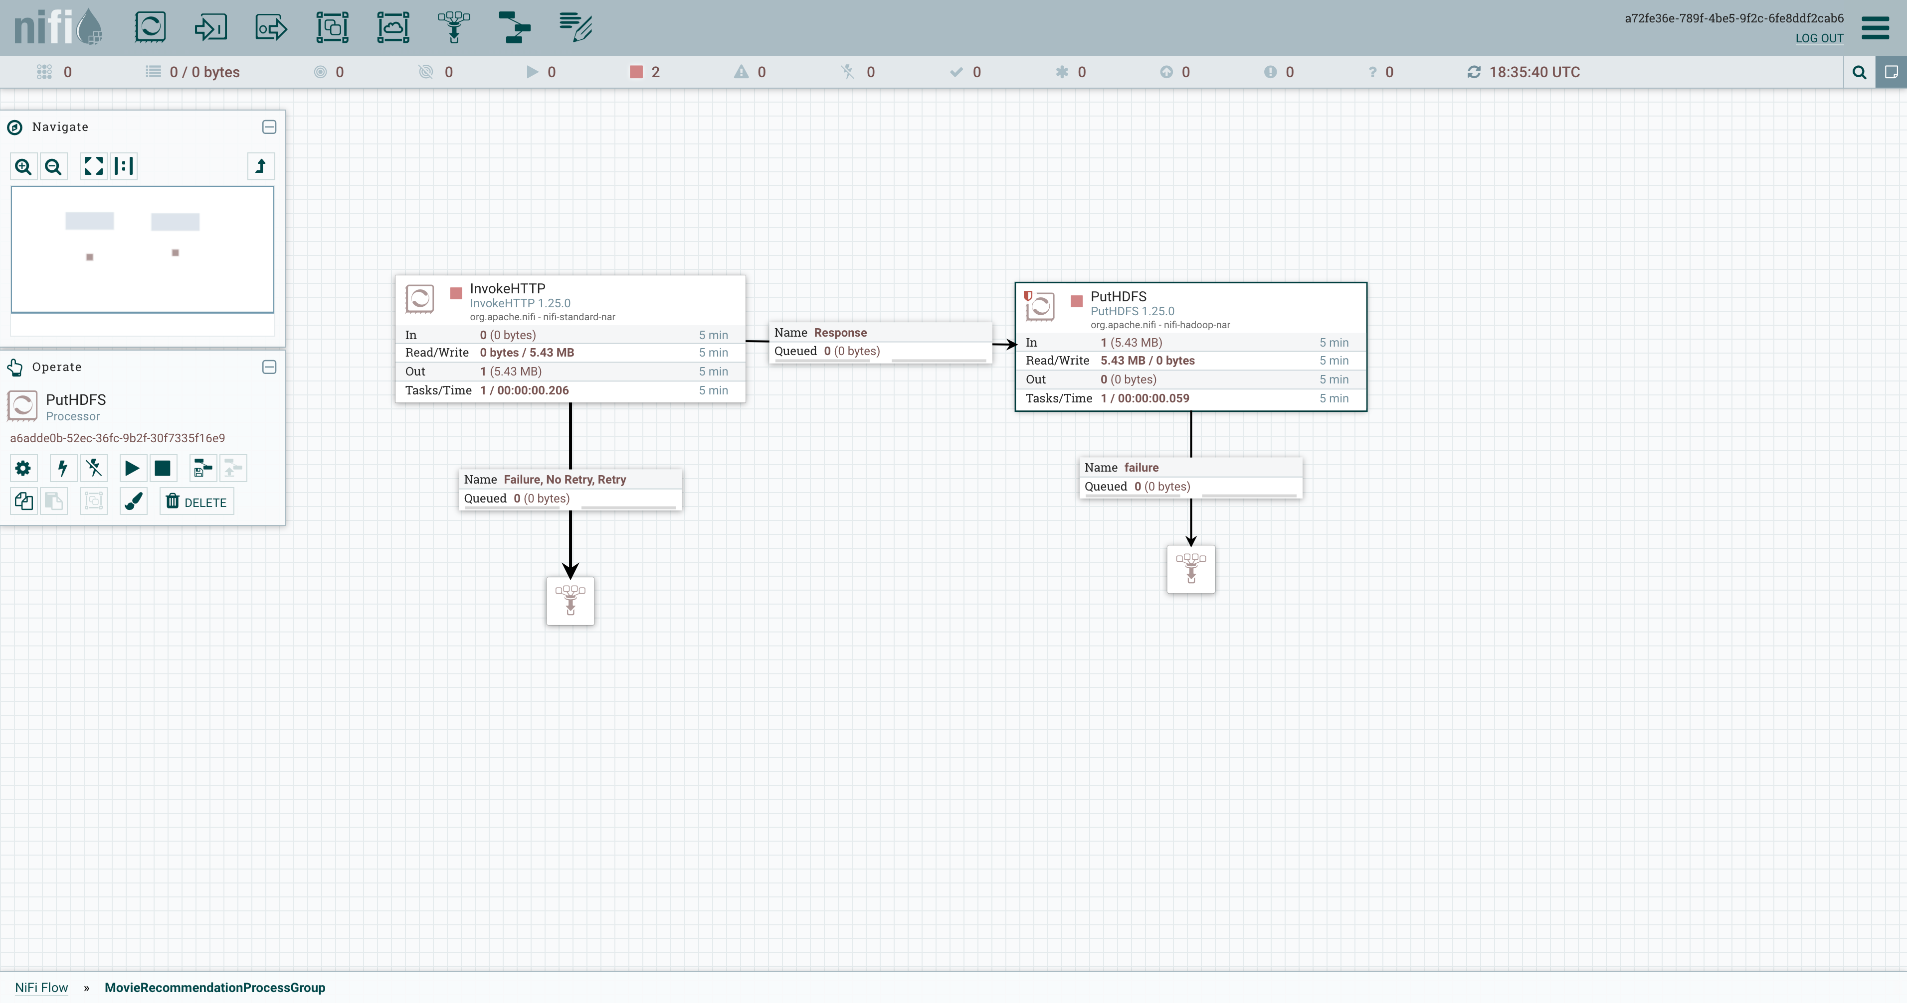

### HDFS Verification

#### Verify the data in hdfs directory

|  |
| --- |
| hdfs dfs -ls /movie-data |

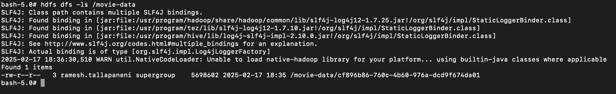

#### Verify the content in hdfs file

|  |
| --- |
| hdfs dfs -cat /movie-data/cf896b86-760c-4b60-976a-dcd9f674da01 | head -n 100 |

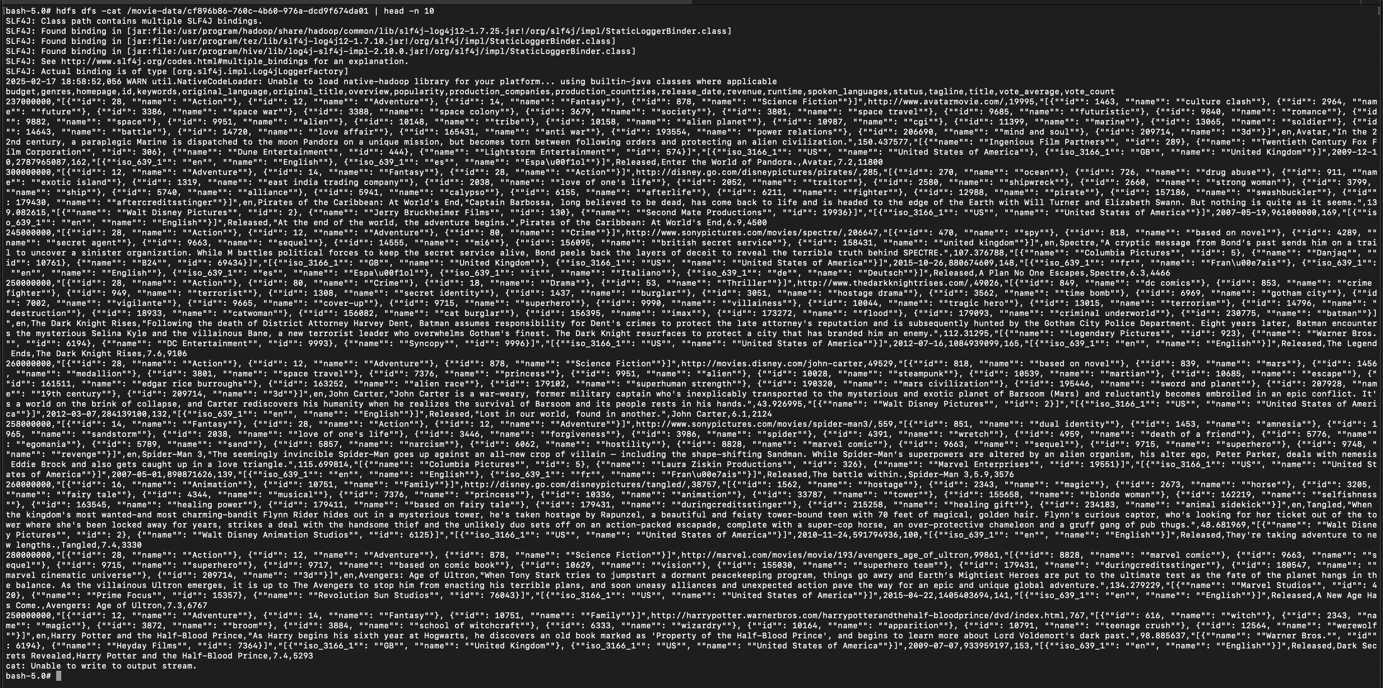

#### Rename the file in hdfs

|  |
| --- |
| hdfs dfs -mv /movie-data/cf896b86-760c-4b60-976a-dcd9f674da01 /movie-data/tmdb_5000_movies.csv |

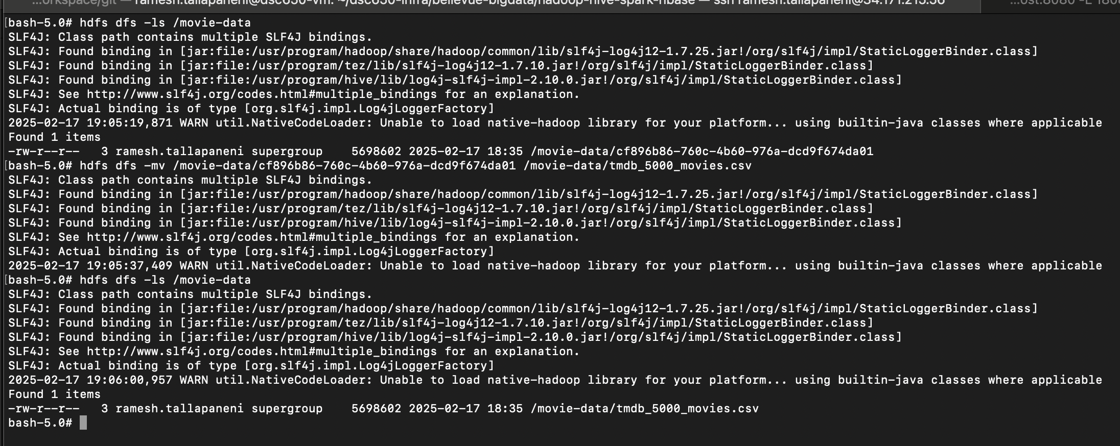

### Manage Hive

#### Create hive table

|  |
| --- |
| CREATE TABLE movies (  budget BIGINT,  genres STRING,  homepage STRING,  id INT,  keywords STRING,  original_language STRING,  original_title STRING,  overview STRING,  popularity DOUBLE,  production_companies STRING,  production_countries STRING,  release_date STRING,  revenue BIGINT,  runtime DOUBLE,  spoken_languages STRING,  status STRING,  tagline STRING,  title STRING,  vote_average DOUBLE,  vote_count INT  )  ROW FORMAT DELIMITED  FIELDS TERMINATED BY ','  LINES TERMINATED BY '\n'  STORED AS TEXTFILE  TBLPROPERTIES ("skip.header.line.count"="1"); |

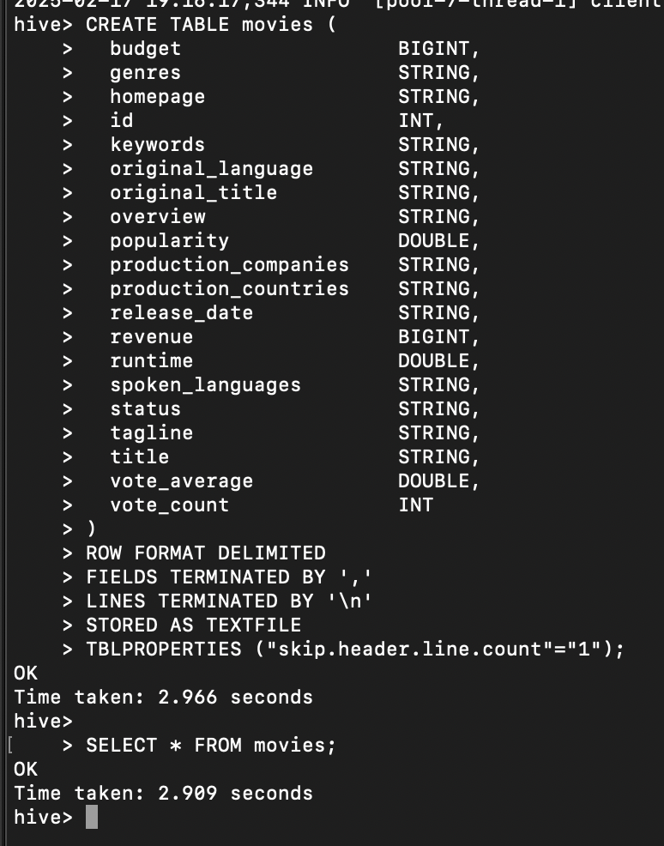

#### Load movie data into hive table

|  |
| --- |
| LOAD DATA INPATH '/movie-data/tmdb_5000_movies.csv' INTO TABLE movies; |

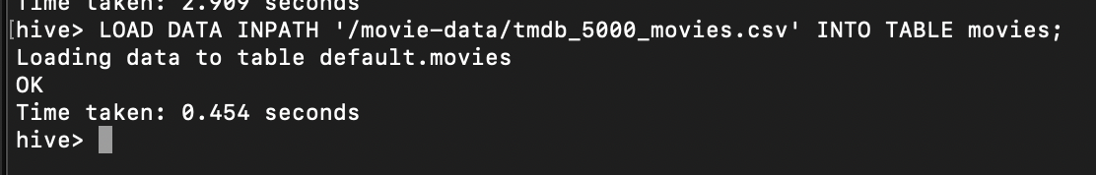

#### Verify data in hive table

|  |
| --- |
| SELECT * FROM movies; |
| SELECT count(*) FROM movies; |
| SELECT * FROM movies WHERE id= 281189; |
| EXPLAIN SELECT count(*) FROM movies; |
| EXPLAIN SELECT * FROM movies WHERE id=28; |

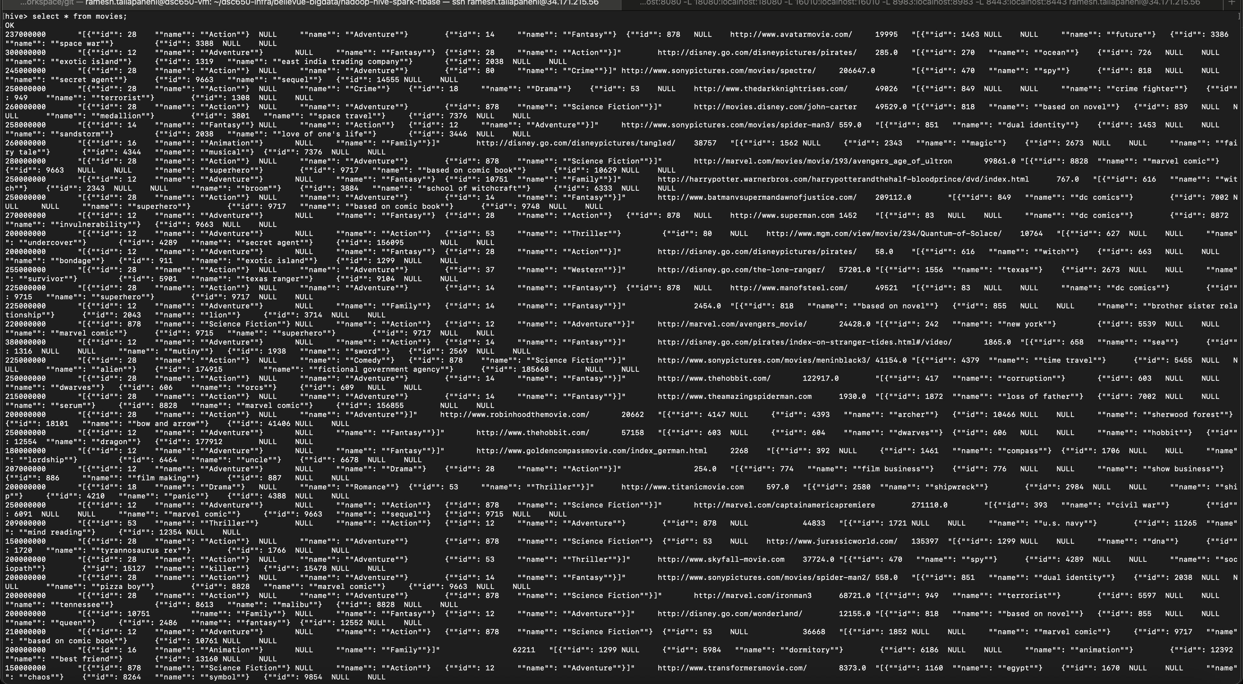



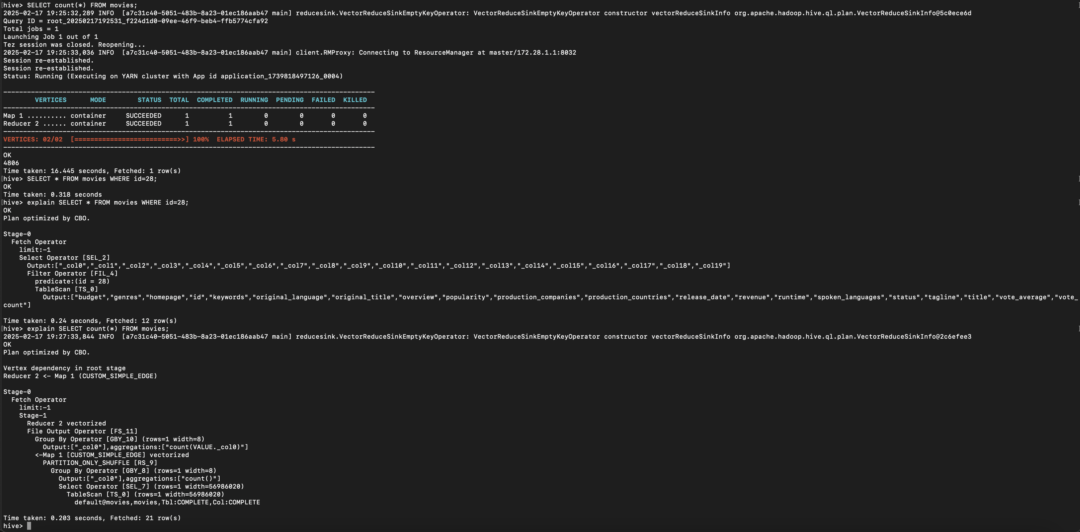

### Manage PySpark

#### Create PySpark session

|  |
| --- |
| import org.apache.spark.sql.SparkSession |
| val spark = SparkSession.builder  .appName("Movie Recommendation Scala Spark Session")  .enableHiveSupport()  .getOrCreate() |

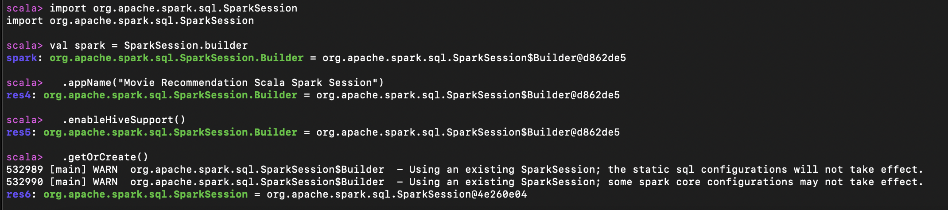

#### Execute Queries

##### Select all movies

|  |
| --- |
| import org.apache.spark.sql.SparkSession  object ScalaHiveQuery {  def main(args: Array[String]): Unit = {    // Step 1: Create or get the SparkSession with Hive support  val spark = SparkSession.builder()  .appName("Movie Recommendation - Scala")  .enableHiveSupport()  .getOrCreate()  // Step 2.2: Query the Hive table  val df = spark.sql("SELECT * FROM movies")  // Step 2.3: Show the result  df.show()    // Step 2.4: Stop the Spark session (optional)  spark.stop()  }  } |
| ScalaHiveQuery.main(Array.empty) |

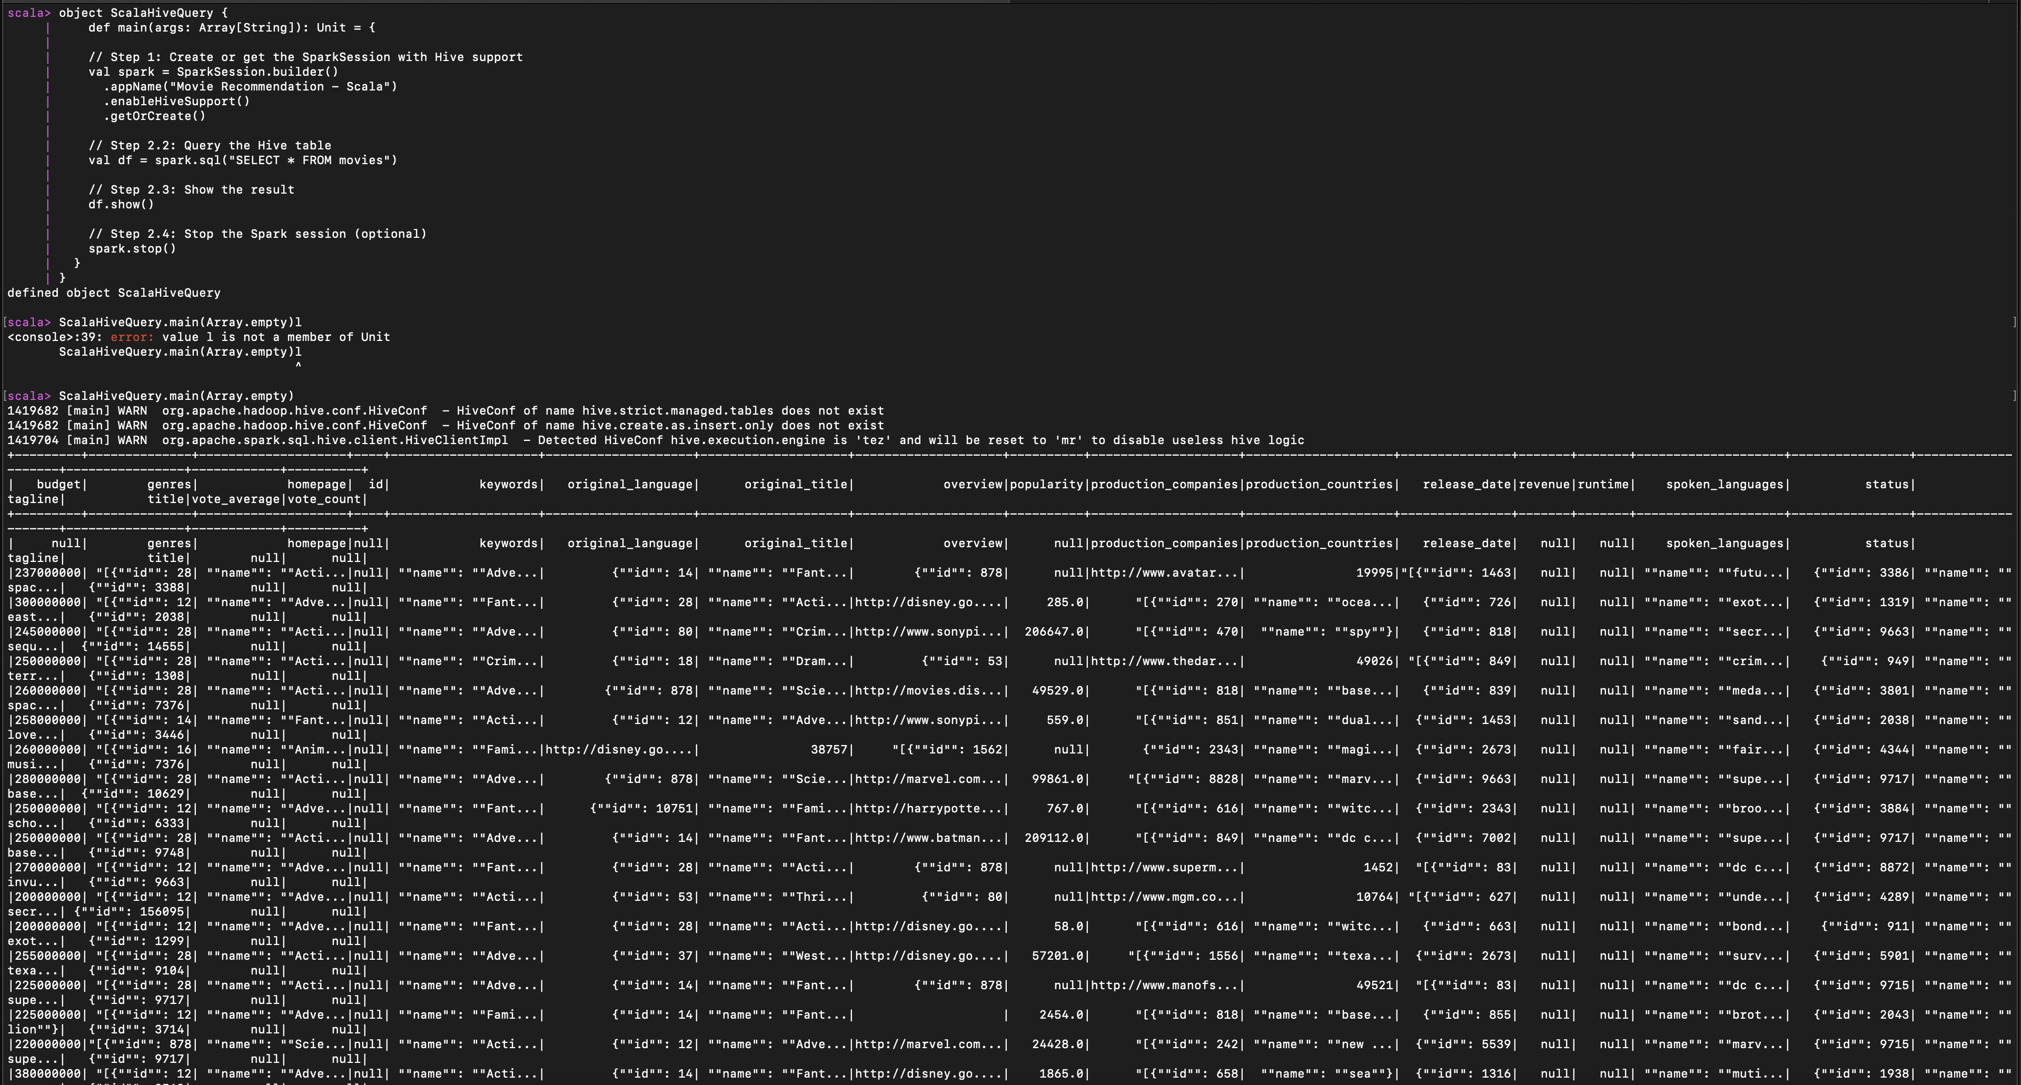

##### Select specific movie record by id

|  |
| --- |
| import org.apache.spark.sql.SparkSession  object ScalaHiveQuery {  def main(args: Array[String]): Unit = {    // Step 1: Create or get the SparkSession with Hive support  val spark = SparkSession.builder()  .appName("Movie Recommendation - Scala")  .enableHiveSupport()  .getOrCreate()  // Step 2.2: Query the Hive table  val df = spark.sql("SELECT * FROM movies WHERE id= 281189")  // Step 2.3: Show the result  df.show()    // Step 2.4: Stop the Spark session (optional)  spark.stop()  }  } |
| ScalaHiveQuery.main(Array.empty) |

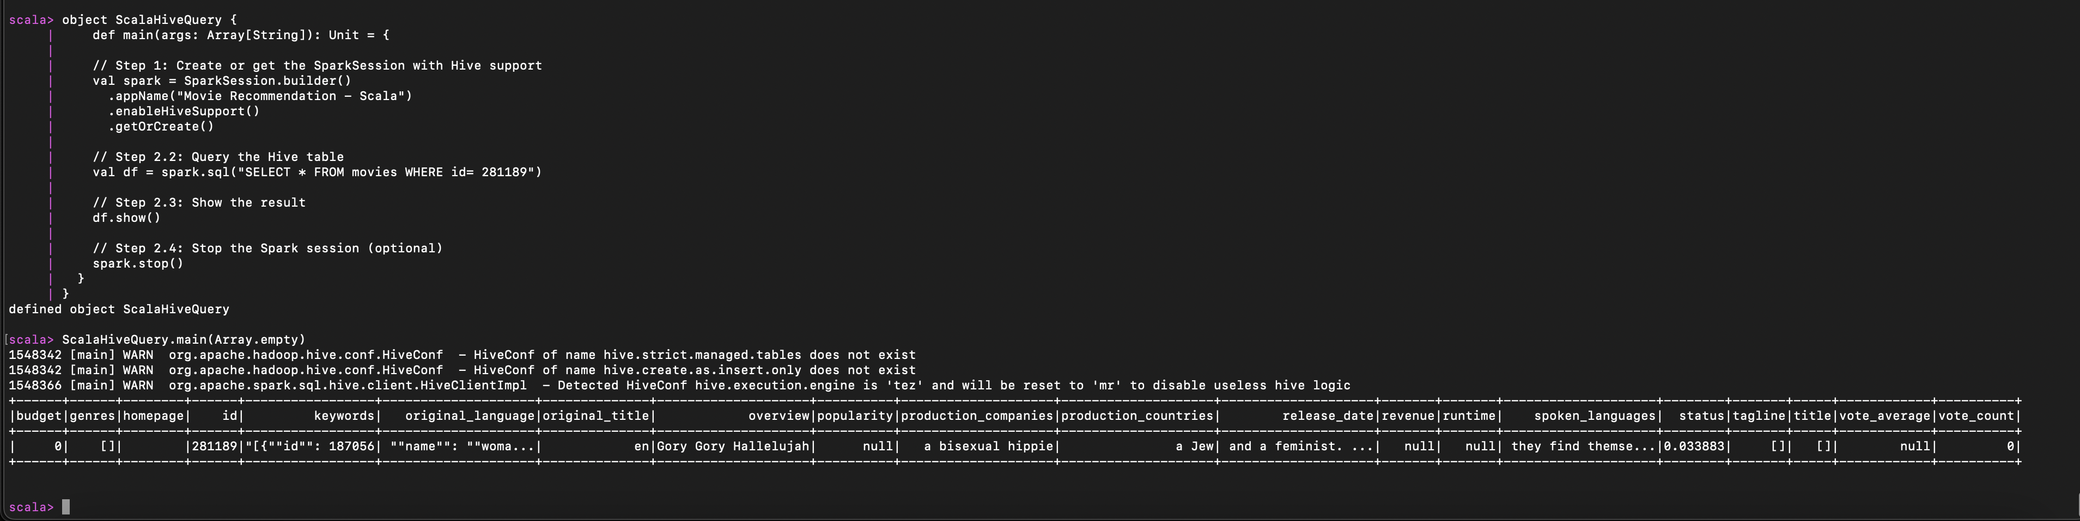

# Issues

## Issue with pipeline configuration to connect with hdfs

* Below issue is resolved by updating the path to

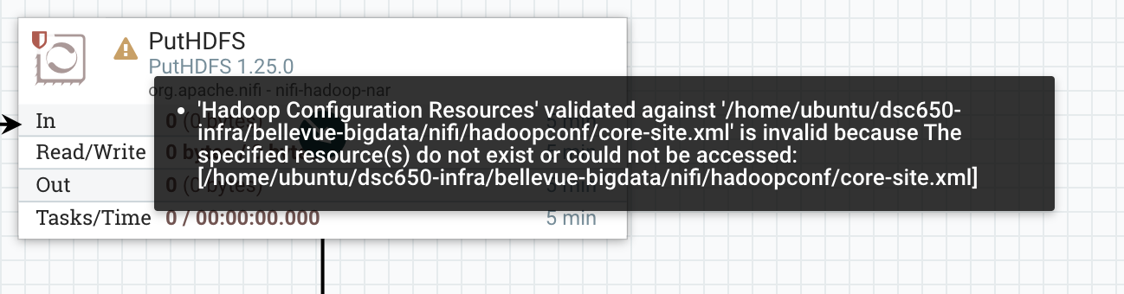

## Issues with execution causing data duplication

* Executing the pipeline is causing the activity to repeat, that means it’s downloading the same file multiple times and uploading to hdfs causing data duplication
* Solution is to run the pipeline once, instead of keeping it in run status

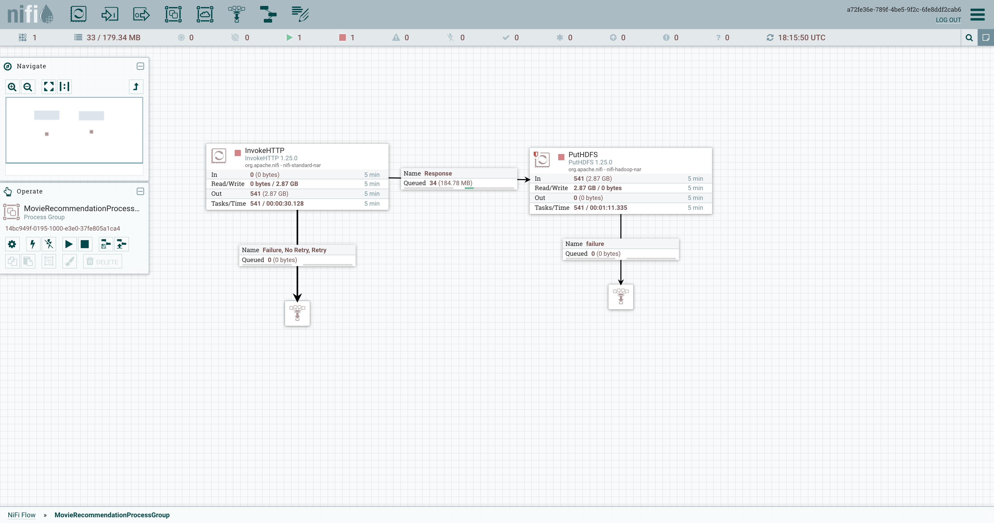

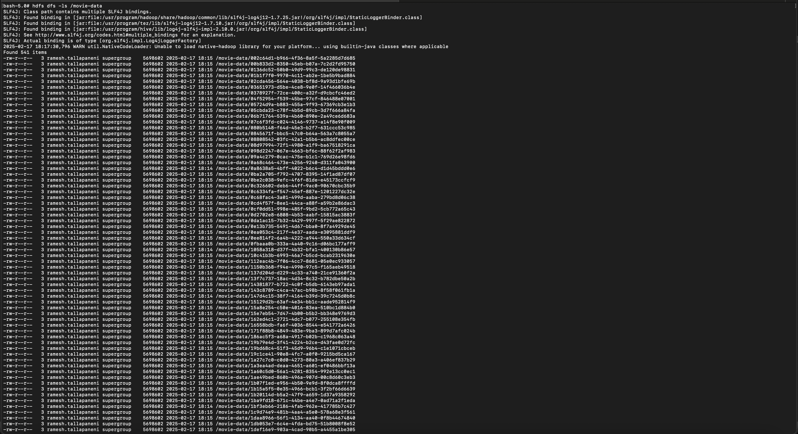

## Issue with opening a huge file in HDFS

* Opening a file of size 5.43 MB in hdfs with -cat command caused the system to froze.
* Solution is to view partial data using commands like **head -n 100** or **less**